Winterbourne Stoke Parish Council

NOTICE OF MEETING AND SUMMONS TO ATTEND

The Winterbourne Stoke Annual Parish Meeting
will be held in the Education Suite,
Stonehenge Visitor’s Centre, Winterbourne Stoke
on Monday 26th March 2018 at 6.00 pm

AGENDA

- Chairman’s opening comments.

- Presentation by Highways England on the A303 Amesbury Stonehenge
to Berwick Down Scheme.

- Statement by the Chairman of the Parish Council on the A303 Amesbury
Stonehenge to Berwick Down Scheme.

- Open forum for residents’ questions and discussion.

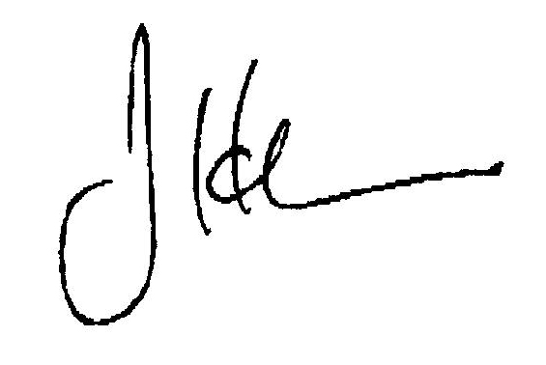

J H Carr
Clerk of the Council 27th February 2018

