Winterbourne Stoke Parish Council

NOTICE OF MEETING AND SUMMONS TO ATTEND

A Meeting of the Winterbourne Stoke Parish Council will be held in
The Stonehenge Visitor’s Centre, Winterbourne Stoke, on
Monday 26th March 2018 following the Annual Parish Meeting.

AGENDA

1. Chairman’s opening statement.
2. Adjournment for Residents’ questions.
3. To confirm the minutes from the Council meeting held on 15th January 2018.
4. To report, for information only, any matters arising from the minutes.
5. Planning Applications.
6. Services, including Recreation Facilities.
- Play Park
- Broadband
- Website
- Telephone Box
- Defibrillator
7. Highways and Byways.
- General
- Church Street
- A303
- Bypass
8. Environment, including Emergency Planning.
9. World Heritage Site.
10. Police.
11. Finance.
12. Reports from Cllrs and the Village Events Committee.
13. Correspondence received since the last meeting.

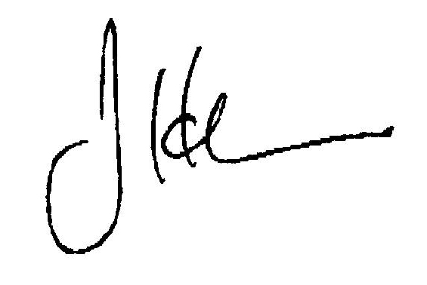
J H Carr
Clerk of the Council 26th February 2018

