Winterbourne Stoke Parish Council

NOTICE OF MEETING AND SUMMONS TO ATTEND

A Meeting of the Winterbourne Stoke Parish Council
will be held in The Solstice Rest, Winterbourne Stoke
on Monday 16th January 2017 at 7.00 pm.

AGENDA

1. Chairman’s opening statement.
2. Adjournment for Residents’ questions.
3. To confirm the minutes from the Council meeting held on 21st November 2016
4. To report, for information only, any matters arising from the minutes.
5. Planning Applications.
6. Services, including Recreation Facilities.
- Play Park
- Broadband
- Website
7. Highways and Byways.
- General
- A303
8. Environment, including Emergency Planning.
9. World Heritage Site.
10. Police.
11. Finance.
12. Reports from Parish Cllrs, Wiltshire Cllrs and the Village Events Committee.
13. Correspondence received since the last meeting.

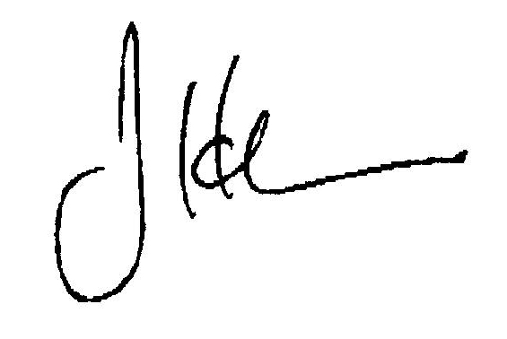

J H Carr
Clerk of the Council 3rd January 2017

