 | Salisbury Plain Training Area  Newsletter  NOVEMBER 2016
www.gov.uk/government/publications/salisbury-plain-training-area-spta-newsletter
This Newsletter can be found at the above link

The DIO runs a Twitter account for news and updates on the Salisbury Plain Training Area using the Twitter hashtag #modontheplain. This account now has over 3450 followers. If you’d like to follow us go to: www.twitter.com/mod.dio

November 2016 Newsletter

November is the start of EX WESSEX STORM, 1-20 Nov, with 4 SCOTS, a mechanized BG. They will be exercising from Warminster West to Tidworth East conduction challenging operations. There are also infantry company and armoured squadrons excercising at varying times during the month: a very busy time on the plain.
Safety is all important. There is live firing from all weapon systems including AS90 from 19 Regiment, Royal Artillery and various infantry sections of mortars. It should be noted that late night firing on Tuesday and Thursday evening will finish at 2100hrs.

Safety: The public should be aware that tank crossings over the A360, A345, A338, B390, and the C22 (Tilshead to Chitterne) roads will be very busy and if conditions are wet mud clearance parties will be working on the crossings. Notice is also given that the training areas in the Copehill Down and Bourne Valley (SPTA East) areas will be heavily used over this period and that recreational use of the Salisbury Plain military lands is to be restricted to public rights of way only as per the byelaws.

Related News
Sanctuary Magazine celebrates 40 years

Related Links
Gov.uk/DIO

A leaflet on public access to Imber is available online and should be read in advance of any visit: https://www.gov.uk/government/uploads/system/uploads/attachment_data/file/435909/Imber_A5_Leaflet-final_Online_version.pdf

Information about low flying is available from the MOD Low Flying Advisory Service (0845 600 7580) or on line at www.gov.uk/low-flying-in-your-area .

MONTHLY FIRING CALENDAR FOR NOVEMBER 2016 (Subject to Change)

- ARTILLERY LIVE FIRING DAYS FROM AREAS 6, 7 AND 8: Nil

- ARTILLERY LIVE FIRING DAYS ON SALISBURY PLAIN (EAST): Nil

- LATE FIRING DAYS ON LARKHILL/WESTDOWN DANGER AREA:
01, 03, 08, 10, 15, 17, 22, 24, 26, 27

- NON- FIRING DAYS ON LARKHILL/WESTDOWN DANGER AREA:
05, 06, 12, 13, 19, 20,

5. NON- FIRING DAYS ON BULFORD RANGES
05, 06, 12, 13, 26, 27

Note: Due to Exercise Wessex Storm Range 2 Flags will be flown from Thu 03 – Mon 21.

Note: All Complaints/Enquiries should be made to 01980 620819.

ACCESS

Access to SPTA is regulated by Salisbury Plain Military Lands, Bulford, Larkhill and Imber Range Byelaws. Always comply with local signs and flags. Rights of way in Range Danger Areas are closed when red flags are flying.

This Newsletter is published up to 6 weeks before the event and changes may occur. Access timings for the next week can be found on the SPTA Walks Line: (01980) 674763.

Imber Ranges. The public are excluded except when the roads are specifically opened. Planned open dates for 2016 are as follows:

Event Open Closed

Remembrance Sunday
(Imber church only) 09.00hrs Sat 12 Nov 16 13.00hrs Sat 12 Nov 16

Christmas / New Year 18.00hrs Fri 16 Dec 16 08.00hrs Mon 03 Jan 17

1. Even when roads are open the village and buildings remain out of bounds to the public.

2. Dates may change if operational training needs dictate.

WHAT CAN YOU DO TO REDUCE CRIME ON SALISBURY PLAIN?

If any crime is taking place call 999, (or 101) and do not under any circumstances challenge the offenders.

The new Rural Crime Partnership for Wiltshire and Swindon (hereafter ‘the Rural Crime Partnership’) has been established by Wiltshire Police in consultation with the Police and Crime Commissioner (PCC) for Wiltshire and Swindon to provide governance for, and oversee delivery of, rural crime strategy. It provides coherence, direction and guidance to the delivery and apportionment of rural policing resources across the county in the context of the Community Policing Model. The first meeting was held at Wiltshire Police Headquarters on 18th October 2016; this is seen by Headquarters SPTA as a positive initiative in order to prevent crime and anti-social behaviour on Salisbury Plain.

Members of the Rural Crime Partnership for Wiltshire and Swindon

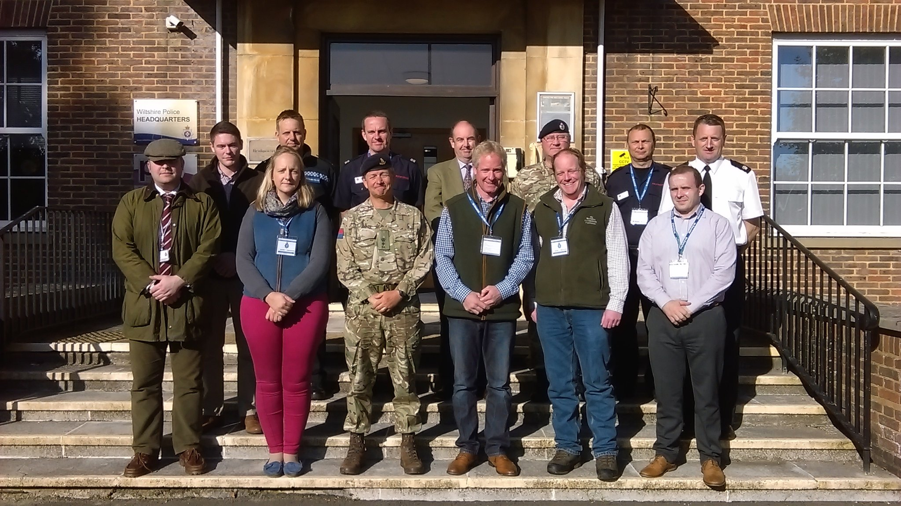

Report suspicious activity to PLAINWATCH (01980 674700) or PLAINWATCH@landmarc.mod.uk. The more information received the better, e.g. time, place, vehicle registration, description of individuals and vehicles.

Health and Safety reminder for all Military Training Areas and Ranges:

- Do not touch or tamper with Military debris.
- Wash your hands before you eat.
- Clean your footwear before you enter your car or home.

Jim Russell
WO2 (DTSO)
for
Senior Training Safety Officer Salisbury Plain

